**RELAY CONTROLLING AN EXTERNAL SYSTEM**

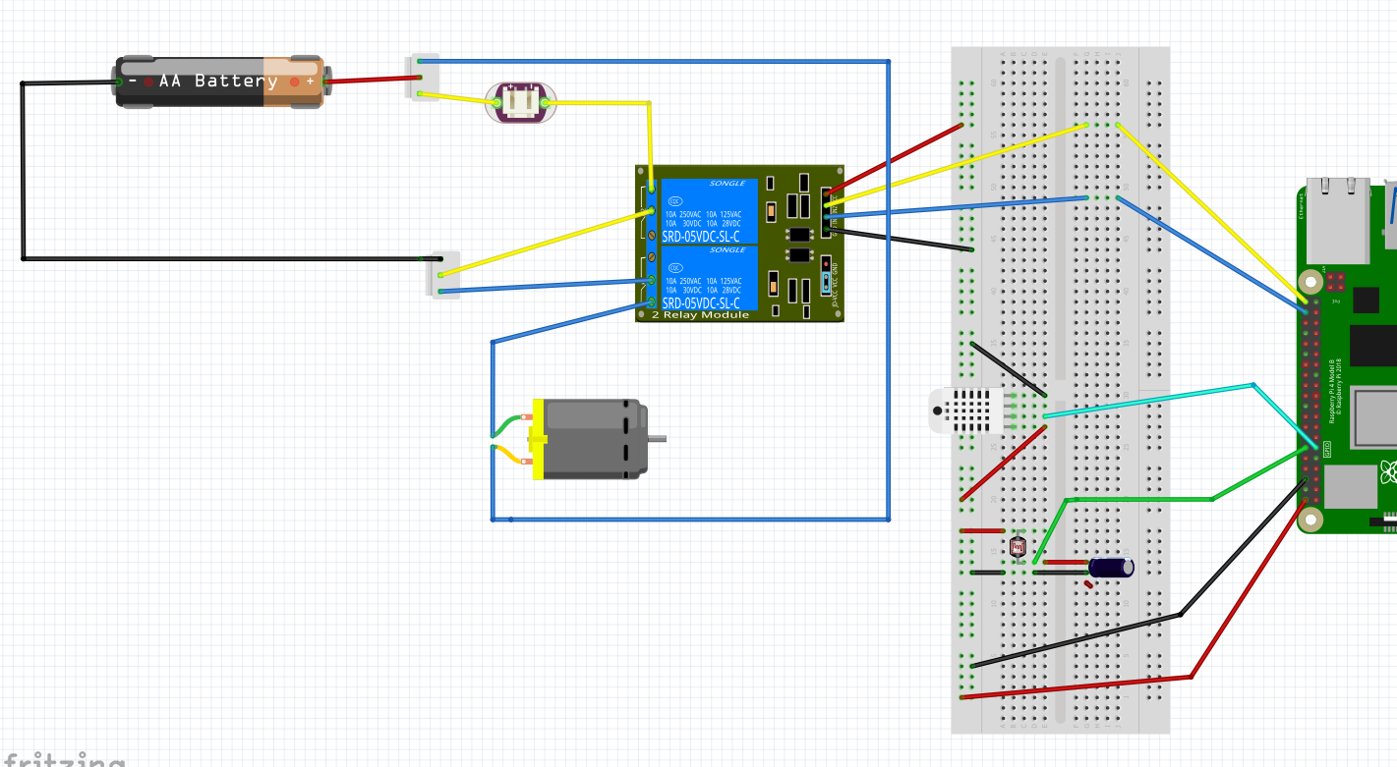

TIME TO CHARGE CAPACITOR DEPENDS

ON RESISTANCE OF LDR WHICH DEPENDS ON LIGHT FALLING ON IT. SHORTER=BRIGHTER, LONGER=DARKER

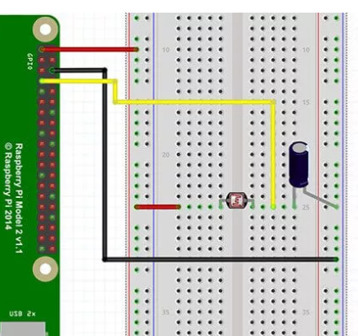

**IN1**

**IN2**

**IN2**

**IN1**

**PIN 21**

**LIGHTS**

**PIN 20**

**MOTOR**

**PIN 17**

**PIN 18**

**LDR**

**10 uf Capacitor**

**D**

**G**

**V**

**THIS CIRCUIT USES NORMALLY OPEN**